SAT Math Problems

1.  What value of x is the solution to the equation $15x−9=6x+12$?

2.  A city is planning to build a series of parks to accommodate the rising urban population. Each park will be in the shape of a rectangular prism, with a height of 15 feet. If the length of the park’s base is represented by the variable y feet, and its width is 2 feet less than the length, which function P gives the volume of the park in cubic feet in terms of the length of the park’s base?

A. $P(y)=15y^{2}+30y$

B. $P(y)=15{\left(y−2\right)}^{2}$

C. $P(y)=15y^{2}−30y$

D. $P(y)=y^{2}−2y+15$

3.  What is the y-intercept of the function $f(x)=5{\left(2\right)}^{x}$ in the xy-plane?

A.   1

B.   3

C.   5

D.   7

4.  For the linear function g, the graph of $y=g(x)$ in the $xy$-plane has a slope of 12 and passes through the point (0, 5). Which equation defines g?

A. $y=12x+5$

B. $y=12x−5$

C. $y=−12x+5$

D. $y=5x+12$

5.  Which of the following equations best represents the line of best fit shown in the scatter plot? 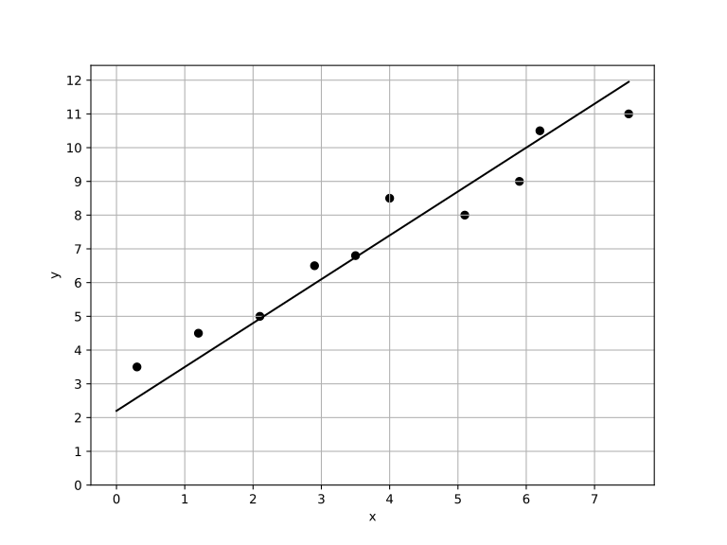

A. $y=2.2+1.3x$

B. $y=2.2−1.3x$

C. $y=−2.2+1.3x$

D. $y=−2.2−1.3x$

6.  The table gives the perimeters of similar triangles DEF and GHI, where DE corresponds to GH. If the length of DE is 16, what is the length of GH? 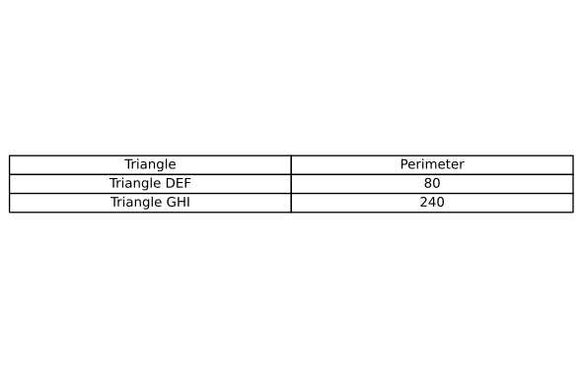

A.   24

B.   32

C.   48

D.   64

7.  The equation relates the quantities a, x, and z. Which equation correctly expresses x in terms of a and z? $a+25=\frac{x}{z}$

A. $x=\frac{a+25}{z}$

B. $x=\frac{z}{a+25}$

C. $x=a+25z$

D. $x=az+25z$

8.  The function R models the number of devices connected to a 5G network in millions, t years after 2020. The growth of the network follows the model: $R(t)=50{\left(1.05\right)}^{4t}$. What is the annual percentage growth rate of devices connected to the 5G network based on this model?

9.  A wind turbine generates electricity at a constant rate of 15 kilowatts per hour. If this turbine operates for $h$ hours, the total electricity generated, represented by the function , can be given by the equation . How many kilowatts of electricity does this turbine generate after 5 hours? Additionally, how much electricity is generated per hour?

A.    70, 12

B.    75, 15

C.    80, 18

D.    65, 10

10.  Circle A has a radius of 5 centimeters (cm). Circle B has an area of $64πcm^{2}$. What is the total area, in $cm^{2}$, of circles A and B?

SAT Math Solutions

1.  What value of x is the solution to the equation $15x−9=6x+12$?

## Answer

$\frac{7}{3}$

## Solution

This problem tests the student’s ability to solve basic linear equations. The student needs to understand the concept of isolating the variable on one side of the equation to find its value.  
To solve this equation, the student should first move all terms containing x to one side and constant terms to the other side. This can be done by subtracting 6x from both sides to get $9x−9=12$. Then, add 9 to both sides to obtain $9x=21$  
Always simplify the equation step by step. After moving terms, check to ensure all x terms are on one side and constants on the other. Simplify fractions if possible at the end to get the final answer.  
Be careful with the signs when moving terms from one side to the other. It’s easy to make a mistake with positive and negative signs, which can lead to the wrong answer. Also, ensure to simplify your final answer.  
This type of problem is fundamental in algebra and is crucial for understanding more complex equations. It’s important to master these basic steps of moving terms and simplifying, as they form the foundation for solving a variety of algebraic problems on the SAT. Practice will help in reducing errors and increasing speed in solving such equations.  
  
Start with the equation: $15x−9=6x+12$.  
Subtract 6x from both sides to gather x terms on one side: $15x−6x−9=12$.  
This simplifies to: $9x−9=12$.  
Add 9 to both sides to isolate the x term: $9x−9+9=12+9$.  
This gives: $9x=21$.  
Divide both sides by 9 to solve for x: $x=\frac{21}{9}$.  
Simplify the fraction: $x=\frac{7}{3}$.  
The solution is $x=\frac{7}{3}$, which is the improper fraction form.

2.  A city is planning to build a series of parks to accommodate the rising urban population. Each park will be in the shape of a rectangular prism, with a height of 15 feet. If the length of the park’s base is represented by the variable y feet, and its width is 2 feet less than the length, which function P gives the volume of the park in cubic feet in terms of the length of the park’s base?

A. $P(y)=15y^{2}+30y$

B. $P(y)=15{\left(y−2\right)}^{2}$

C. $P(y)=15y^{2}−30y$

D. $P(y)=y^{2}−2y+15$

## Answer

C

## Solution

The problem aims to assess the student’s understanding of polynomial functions and their application in real-world scenarios. Specifically, it tests the ability to set up and manipulate expressions for volume in terms of polynomial functions.  
To solve this problem, students need to understand the formula for the volume of a rectangular prism, which is length × width × height. Given the height and the relationship between length and width, students need to express the width in terms of the given variable y and then set up a function P(y) representing the volume.  
Start by explicitly writing down the relationships: the width is y - 2 feet, and the height is 15 feet. Then substitute these values into the volume formula. Remember, the expression for the volume will be a polynomial in terms of y.  
Be careful not to confuse the dimensions. Ensure you subtract correctly when determining the width. Also, watch out for simple arithmetic errors when expanding the polynomial expression.  
This problem is a classic example of applying algebraic concepts to geometric shapes, a skill frequently tested in SAT Math. It evaluates the ability to derive expressions from given conditions and manipulate them into the required format. Mastering these types of problems will boost your confidence in handling complex word problems involving polynomials.  
  
Using the formula $V=length×width×height$, plug in the values for length, width and height: $V=y×(y−2)×15$  
First, multiply y by (y - 2):, $y(y−2)=y^{2}−2y$, Then multiply the result by the height 15: $V=15(y^{2}−2y)$  
Distribute the 15: $V=15y^{2}−30y$  
Thus, the function P that gives the volume of the park is $P(y)=15y^{2}−30y$.

3.  What is the y-intercept of the function $f(x)=5{\left(2\right)}^{x}$ in the xy-plane?

A.   1

B.   3

C.   5

D.    7

## Answer

C

## Solution

This problem is designed to test the student’s understanding of exponential functions and specifically their ability to determine the y-intercept of such a function.  
To find the y-intercept of the function, the student needs to evaluate the function at $x=0$. This is because the y-intercept is the point where the graph intersects the y-axis, which occurs when x is 0.  
Remember that for any function $y=f(x)$, the y-intercept can be found by calculating $f(0)$. For exponential functions of the form $y=a{\left(b\right)}^{x}$, substitute $x=0$ to find the y-intercept as $a×b^{0}=a$.  
Be careful not to confuse the x-intercept with the y-intercept. The x-intercept occurs when $y=0$, which is not relevant in this problem. Also, remember that any number raised to the power of 0 is 1.  
This type of problem is straightforward once you understand the concept of the y-intercept in a function. It evaluates the student’s ability to apply basic principles of exponential functions and substitution. Mastering this concept is crucial as it is foundational for solving more complex problems involving exponential growth and decay in the SAT math section.  
  
Set $x=0$ in the function: $f(0)=5{\left(2\right)}^{0}$.  
Simplify the expression: $2^{0}=1$, so $f(0)=5×1$.  
Thus, the y-intercept is $f(0)=5$.

4.  For the linear function g, the graph of $y=g(x)$ in the $xy$-plane has a slope of 12 and passes through the point (0, 5). Which equation defines g?

A. $y=12x+5$

B. $y=12x−5$

C. $y=−12x+5$

D. $y=5x+12$

## Answer

A

## Solution

This problem tests the student’s understanding of the equation of a linear function, specifically identifying and using the slope-intercept form. It checks if the student knows how to apply the concept of slope and y-intercept to find the equation of a line.  
To solve this problem, the student should recognize that the slope-intercept form of a linear equation is y = mx + b, where m represents the slope and b represents the y-intercept. Given the slope (m) is 12 and the y-intercept (b) is 5 (since the line passes through (0, 5)), the equation becomes $y=12x+5$.  
Remember that in the slope-intercept form $y=mx+b$, m is the slope and b is the y-intercept, which is the point where the line crosses the y-axis. Substitute the given values directly into this form to find the equation quickly.  
Be careful not to confuse the x-intercept with the y-intercept. Also, ensure that you correctly substitute the slope and y-intercept into the equation form without mixing them up. Double-check that the point given (0, 5) confirms the y-intercept directly.  
This problem is straightforward if you are familiar with the slope-intercept form of linear equations. It assesses your ability to interpret and apply basic algebraic concepts in graphing linear functions. Practicing these types of problems can help reinforce your understanding of linear equations and their graphical representations, which are fundamental in algebra. On the SAT, such questions evaluate your capacity to quickly and accurately apply algebraic principles.  
  
For a linear function with slope m and y-intercept b, the equation can be written as $y=mx+b$.  
Given the slope $m=12$ and the line passes through the point (0, 5), the y-intercept (b) is 5.  
Therefore, the equation of the line is $y=12x+5$.

5.  Which of the following equations best represents the line of best fit shown in the scatter plot? 

A. $y=2.2+1.3x$

B. $y=2.2−1.3x$

C. $y=−2.2+1.3x$

D. $y=−2.2−1.3x$

## Answer

A

## Solution

The problem aims to assess a student’s ability to understand and interpret scatter plots, specifically in identifying the line of best fit. It tests the student’s knowledge of linear equations and how they relate to data representation in plots.  
Students should begin by analyzing the scatter plot to identify the general trend of the data points. They must understand that the line of best fit is a line that best represents the data points by minimizing the distance of each point from the line. Then, students should compare the slope and y-intercept of the given linear equations to the trend observed in the scatter plot.  
Focus on the overall direction of the data points. If they generally increase, the slope will be positive; if they decrease, the slope will be negative. Estimate the y-intercept by observing where the line of best fit crosses the y-axis. This helps in matching the visual trend to the correct equation.  
Be wary of outliers that can skew your perception of the line of best fit. Also, ensure you understand the scale of both axes, as misinterpretation can lead to selecting an incorrect equation. Double-check that the slope and y-intercept of your chosen equation logically represent the plotted data.  
This type of question is common in the SAT as it evaluates a student’s ability to connect algebraic concepts with data interpretation. Mastery of scatter plots and the concept of lines of best fit is crucial not only for the SAT but also for real-world data analysis. Understanding these concepts will aid in solving similar problems efficiently.  
  
Looking at the provided graph through code, we can see a positive slope as the general trend of the data points is upwards as x increases.  
The slope and intercept are estimated as $m=1.3$ and $b=2.2$.  
The graph shows that both the slope and the intercept are positive, indicating the option with positive values for both.  
Thus, option 1) $y=2.2+1.3x$ best represents the line of best fit.

6.  The table gives the perimeters of similar triangles DEF and GHI, where DE corresponds to GH. If the length of DE is 16, what is the length of GH? 

A.   24

B.   32

C.   48

D.    64

## Answer

C

## Solution

This problem tests the student’s understanding of the concept of similarity in geometry, particularly focusing on how the perimeters and corresponding side lengths of similar triangles are related.  
To solve this problem, the student should recognize that the perimeters of similar triangles are proportional to the corresponding side lengths. Given the perimeter of both triangles, the student can set up a proportion to find the missing length of GH.  
Remember that the ratio of any pair of corresponding side lengths in similar triangles is equal to the ratio of their perimeters. Use this ratio to set up a proportion between the length of DE and GH.  
Be careful to ensure that the sides being compared are indeed corresponding sides. Also, make sure to solve the proportion correctly to avoid calculation errors.  
This type of problem is common in SAT geometry questions as it assesses the ability to apply the properties of similar figures, which is a fundamental concept in geometry. Mastery of setting up and solving proportions is crucial for these problems. Practicing similar problems can improve speed and accuracy in solving them during the test.  
  
For similar triangles, the ratio of the lengths of corresponding sides is equal to the ratio of their perimeters., Given: DE corresponds to GH, Perimeter of DEF = 80, Perimeter of GHI = 240.  
The ratio of the perimeters is 80:240, which simplifies to 1:3.  
Therefore, the ratio of DE to GH is also 1:3.  
If DE = 16, then GH must be 16 multiplied by this ratio, 3.  
Hence, $GH=16×3=48$.

7.  The equation relates the quantities a, x, and z. Which equation correctly expresses x in terms of a and z? $a+25=\frac{x}{z}$

A. $x=\frac{a+25}{z}$

B. $x=\frac{z}{a+25}$

C. $x=a+25z$

D. $x=az+25z$

## Answer

D

## Solution

This problem tests the student’s ability to manipulate and isolate a variable in an algebraic equation, specifically involving operations with polynomials and fractions.  
To solve for x, you need to express x in terms of a and z. Start by isolating the fraction on one side of the equation by subtracting 25 from both sides, then multiply both sides by z to solve for x.  
Remember that solving for a variable often involves reversing operations. In this case, you need to handle both addition and division to isolate x. Keep your operations clear and systematic.  
A common mistake is forgetting to multiply the entire expression by z. Ensure that you apply operations to both sides of the equation correctly. Also, be cautious with the signs when subtracting and multiplying.  
This problem is a classic example of isolating a variable within an algebraic equation. It assesses algebraic manipulation skills, which are crucial for advanced mathematics. Mastering these skills is essential for solving more complex equations efficiently on the SAT.  
  
Given the equation: $a+25=\frac{x}{z}$.  
Step 1: Multiply both sides by z to eliminate the fraction: $(a+25)z=x$.  
Step 2: Express x in terms of a and z: $x=az+25z$.

8.  The function R models the number of devices connected to a 5G network in millions, t years after 2020. The growth of the network follows the model: $R(t)=50{\left(1.05\right)}^{4t}$. What is the annual percentage growth rate of devices connected to the 5G network based on this model?

## Answer

21.55

## Solution

This problem is designed to test the student’s understanding of exponential growth, specifically in interpreting and manipulating exponential functions. The student should be able to identify the growth factor and convert it into an annual percentage growth rate.  
To solve this problem, the student should recognize that the function $R(t)=50{\left(1.05\right)}^{4t}$ describes exponential growth. The base of the exponent, 1.05, represents the growth factor for each quarter of a year (since the exponent is 4t, meaning four times per year). To find the annual growth rate, the student needs to calculate ${\left(1.05\right)}^{4}$ and then convert this growth factor to a percentage.  
First, calculate ${\left(1.05\right)}^{4}$ to find the annual growth factor. Then, subtract 1 from this result and multiply by 100 to convert it into a percentage. This will give you the annual percentage growth rate.  
Be careful with the interpretation of the exponent. The model describes quarterly growth, so you need to calculate the annual growth factor by compounding the quarterly growth factor four times. Also, ensure that you perform the arithmetic operations accurately to avoid errors in the final percentage.  
This problem is a typical example of how exponential functions are used to model real-world scenarios, such as network growth. It assesses the student’s ability to manipulate and interpret exponential expressions and understand how growth factors translate into percentage growth rates. Mastery of these skills is crucial for solving a wide range of problems in advanced mathematics and real-world applications. By practicing these types of problems, students can improve their proficiency in handling exponential models, a common topic on the SAT.  
  
To find the annual growth rate, we need to determine the equivalent growth factor for one year.  
Given $R(t)=50{\left(1.05\right)}^{4t}$  
this represents growth every quarter, with a quarterly growth factor of 1.05.  
In one year, there are 4 quarters, so we raise the quarterly growth factor to the power of 4 to find the annual growth factor.  
The annual growth factor = ${\left(1.05\right)}^{4}$., Calculate ${\left(1.05\right)}^{4}$: ${\left(1.05\right)}^{2}=1.05×1.05×1.05×1.05=1.21550625$ 
  
The annual growth factor is 1.21550625.  
Subtract 1 from the annual growth factor to determine the percentage increase. $1.21550625−1=0.21550625$ 
  
Convert this decimal to a percentage: $0.21550625×100=21.550625\%$  
Rounding to the nearest whole number, the annual growth rate is approximately 21.55 $\%$.

9.  A wind turbine generates electricity at a constant rate of 15 kilowatts per hour. If this turbine operates for $h$ hours, the total electricity generated, represented by the function , can be given by the equation . How many kilowatts of electricity does this turbine generate after 5 hours? Additionally, how much electricity is generated per hour?

A.    70, 12

B.    75, 15

C.    80, 18

D.    65, 10

## Answer

B

## Solution

The problem tests the student’s ability to understand and apply linear equations in the context of a real-world scenario, specifically focusing on the concept of the mean rate of change and interpreting linear functions.  
First, identify the given linear equation $E(h)=15h$, where $E(h)$ represents the total electricity generated in kilowatts and $h$ represents the number of hours. To find the electricity generated after 5 hours, substitute $h$ with 5 in the equation. Secondly, recognize that the rate of electricity generation per hour is the constant coefficient in the equation, which is 15 kilowatts per hour.  
When dealing with linear equations, always identify the variables and constants clearly.  
Substituting the given values into the equation step-by-step helps to avoid mistakes. Remember that the coefficient of the variable (in this case, 15) indicates the rate of change per unit.  
Ensure that you substitute the correct value for h and perform the multiplication accurately. It’s easy to misinterpret the coefficient; remember that it represents a constant rate in this context. This type of algebra problem is common on the SAT, as it tests a student’s ability to interpret and manipulate linear equations in a real-world context. Understanding how to apply linear functions and calculate mean rates of change is crucial. Practice with similar problems will improve accuracy and speed in solving these questions.  
To find the total electricity generated after 5 hours, substitute $h=5$ into the function $E(h)$:, $E(5)=15×5$, $E(5)=75$  
Therefore, the turbine generates 75 kilowatts of electricity after 5 hours.  
The constant rate of electricity generation per hour is 15 kilowatts.

10.  Circle A has a radius of 5 centimeters (cm). Circle B has an area of $64πcm^{2}$. What is the total area, in $cm^{2}$, of circles A and B?

## Answer

$89π$

## Solution

This problem tests the student’s ability to apply the formula for the area of a circle and to perform basic arithmetic operations to find the total area of multiple circles.  
First, calculate the area of Circle A using the formula for the area of a circle, which is $A=πr^{2}$. Since Circle A has a radius of 5 cm, its area is $25πcm^{2}$. The area of Circle B is already given as $64πcm^{2}$. Add the areas of both circles to find the total area: $25π+64π=89πcm^{2}$.  
Remember that the area of a circle is $πr^{2}$. Make sure to perform the arithmetic operations carefully. Since both areas are already expressed in terms of $π$, you can just add the coefficients of $π$ directly.  
Be careful not to confuse the radius with the diameter. Also, ensure that you do not attempt to multiply $π$ by itself or perform any unnecessary calculations with $π$. The problem requires recognizing that the areas can be directly summed because they both include $π$.  
This problem is a straightforward test of basic geometry knowledge, specifically the calculation of circle areas. It assesses a student’s ability to apply a simple formula and handle algebraic expressions involving $π$. Problems like these are common on the SAT, where understanding fundamental concepts and executing simple calculations accurately are key to success.  
  
Step 1: Calculate the area of Circle A using the formula $A=πr^{2}$.  
Area of Circle $A=π×(5c{m)}^{2}=π×25cm^{2}=25πcm^{2}$.  
Step 2: Add the area of Circle A to the area of Circle B to find the total area. $Total Area=Area of Circle A+Area of Circle B=25πcm^{2}+64πcm^{2}$ 
.  
Step 3: Combine the areas by adding the coefficients of $π$. $Total Area=(25+64)πcm^{2}=89πcm^{2}$ 
.